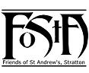
Friends of St Andrew’s Church
Stratton, Cornwall
Newsletter Spring 2019
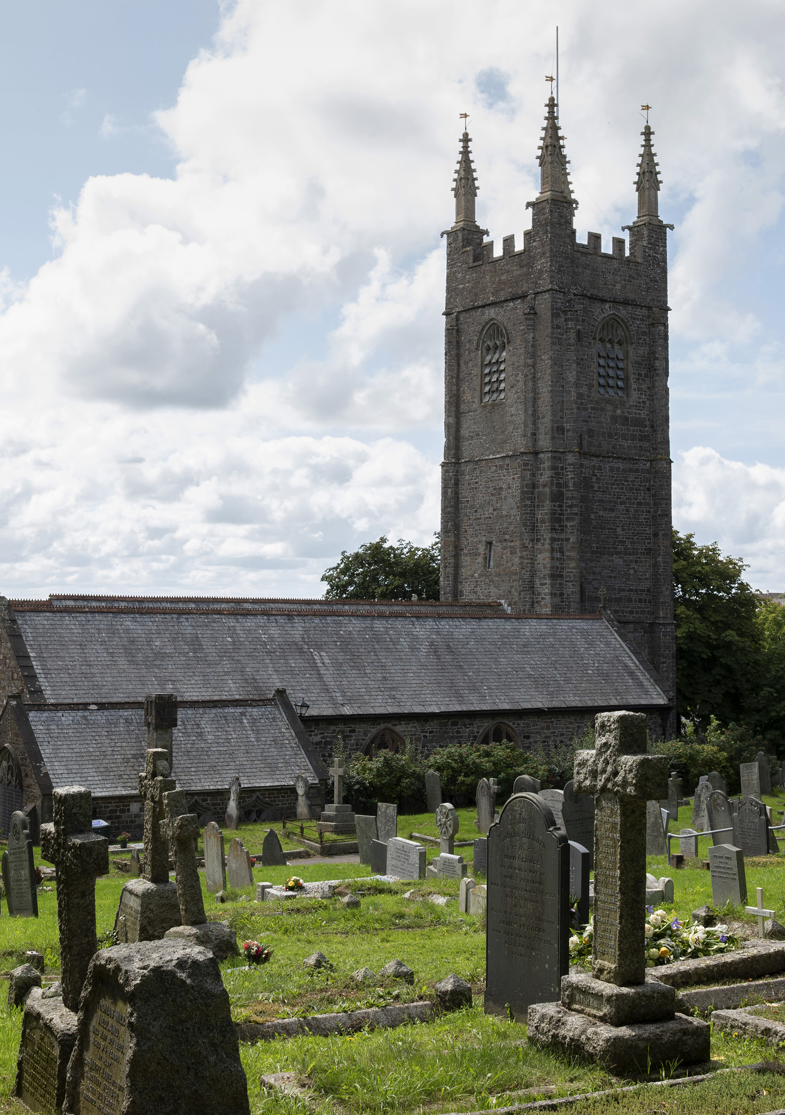
Volume 11 Issue 1

St Andrew’s viewed from the north.
Cover photograph courtesy of Mr David Goodwin JP
Dear Friends,

It is hard to believe that we are now well into the New Year 2019 and yet again St Andrew’s is moving towards a new chapter in its life and witness.

Due to the reorganisation of the Stratton Deanery and the new Cluster groupings we now find ourselves to be in what is known as a Transition – what used to be called a Vacancy or an Interregnum. Members of all the churches in our Northern Cluster (Morwenstow, Kilkhampton, Poughill, Launcells and Stratton) are working hard to prepare a Statement of Needs which will enable us to advertise for a new priest. We pray the Lord will send us someone before too long. Fr David Barnes will be moving to be with the enlarged Central Cluster of Budehaven, Marhamchurch, Week St Mary, Poundstock and Whitstone and will take up residence in the Week St Mary vicarage. As the Rural Dean he will help us out as much as he is able and we are fortunate in having retired priests and lay ministers to continue with the service pattern.
The Diocese has purchased a new home on the Binhamy Estate and that will be the Clergy House for the Northern Cluster when we get the new incumbent. Meanwhile everyone is doing their best to keep things going in order to maintain our worship and service to the community.

In April when the Annual Parochial Church meeting is held, I shall be able to report that the Friends of St Andrew’s have had a very good year both socially and financially. Grants totalling £1,500 have been made to the PCC to help with the maintenance of the churchyard and there are funds held ready for grant-aid towards the final stage of the back of church reorganisation as well as other forthcoming projects. It should be emphasized that at least £11,500 of the money held has been raised from specific donations from Friends and fundraising efforts to help finance the work. It is amazing how supportive our membership continues to be with all we try to do.

Fund raising events organised by the committee and Friends included an Auction, Craft Fayre, Carols and Canapés evening and the sale of Christmas Cards and items from the FoStA shop – all together these realised almost £3,000. The new Christmas card was particularly well received. We are enormously grateful to those who donated items to sell, gave of their time, artistic talents and carpentry skills, offered their homes for hospitality and everyone who gave their support. Nothing happens without volunteers and general help and, thankfully, we have had plenty of willing hands. As well as raising funds these activities did a great deal to enable outreach not only to the Friends but to all in the Parish and surrounding area.

__________________________________________
Developments for the Rear of St. Andrews – Project Update
At the end of September 2018 the second phase of the project for the rear of the church commenced. This comprised the removal of the pews from the rear of church in order to open up this space to enable a more flexible use.
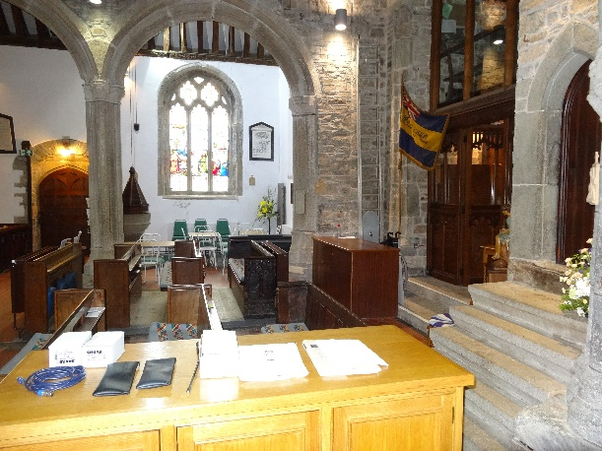
The rear of St Andrews before the removal of the pews, showing the shortage of usable space for social events.

Three pews were removed from each side of the central aisle, but with the historic pew ends on the rear pews reused in alternative locations in the church. The two pew fronts were left in position, firstly as these are engraved with dedications but also because they provide a division between the main body of the church and the multiuse area at the back, separating the spiritual and secular spaces.
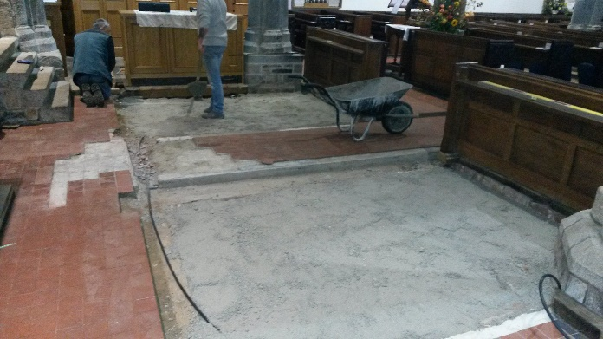
The raised platforms under the pews were removed and the entire floor brought level with the surrounding area and tiled to match. At the same time minor modifications were made as necessary to the heating and electrics.

Work in
progress

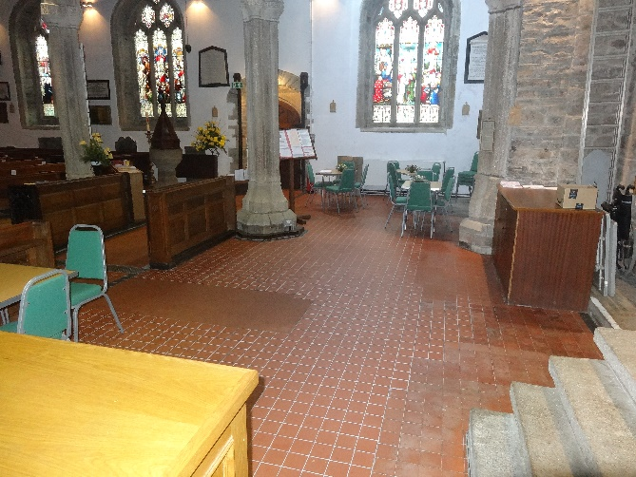

View of the finished space.
Shortly after the work was finished, we were able to make use of the improved space during the October Craft Fair, with tables and chairs being set out for lunches and teas. This proved most successful, a definite improvement over the cramped facilities we were able to provide at previous events. Furthermore, with chairs laid out in the rear area for major services, such as the Christingle and larger funerals, it has been possible to seat more people in the Church than was possible with the fixed pews, a further demonstration of the usefulness of having a flexible space.
Fundraising for the project has continued and we were delighted to receive a grant of £5,000 from the Garfield Weston Foundation. This has given us the confidence to go ahead with the final phase, the relocation of the vestry and installation of the new kitchen, and it is hoped to start this very soon, although based on our current estimates, we will still require a further £5,000 in order to fully fit out the kitchen as we would like.
Simon Waring. Churchwarden
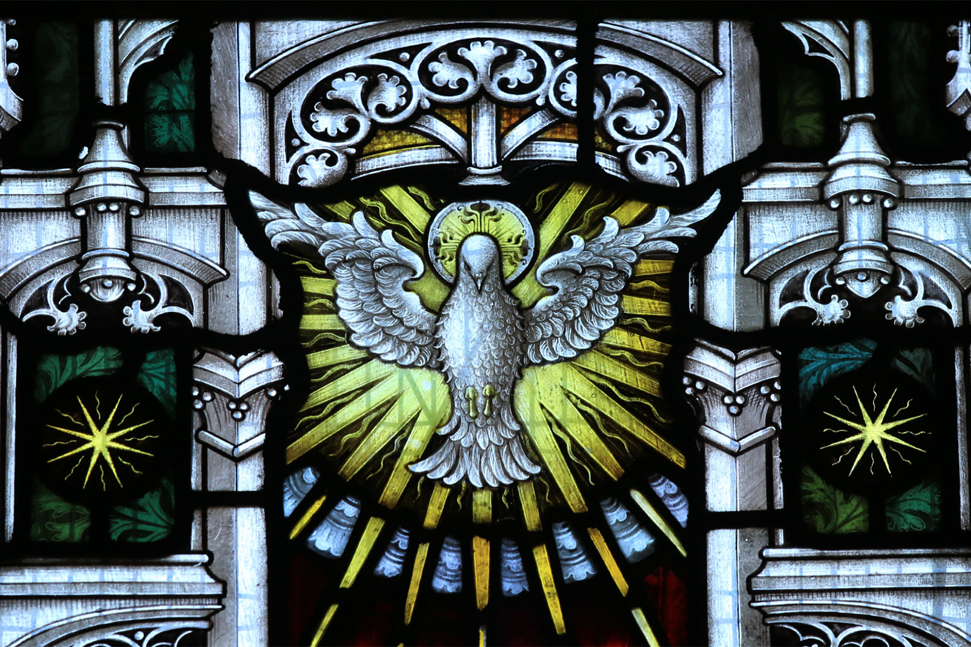

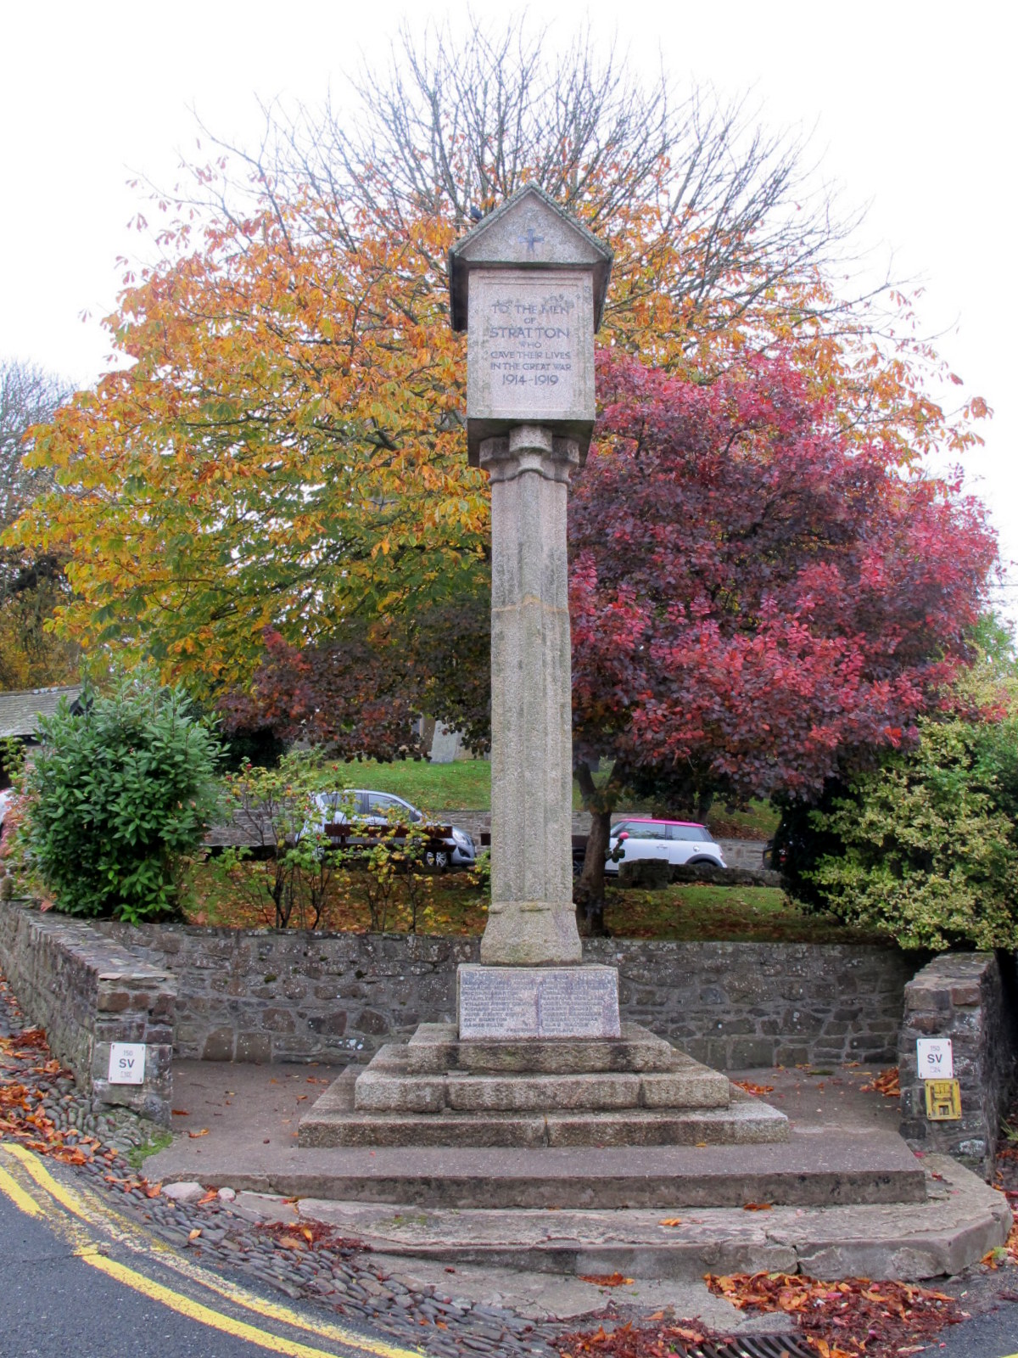
Stratton’s 1918 Armistice Commemoration
As always, Remembrance Sunday worship started around the War Memorial. The priests, cross bearer, flag party and members of the congregation stood and remembered in thought, word and prayer those who had lost their lives. On the upper side of the square, a little way off, stood the cornet party, there to mark the start and finish of the two minute silence.
It seemed somehow very auspicious that the 100th anniversary of the armistice, which brought to an end the slaughter of The Great War, should fall on a Sunday in 2018. In fact Sunday 11th November comes round more often than you might think – about every nine years on average. The next one will be on Sunday 11th November 2029.
For the 100th anniversary it was decided that something special had to be done at St Andrew’s to mark this particularly significant day of commemoration, remembrance and reflection. It was not to be a sad occasion but nevertheless respectful not only for those who gave their lives but also for those who returned. Records show that at least 64 men returned to Stratton from their regiments at the end of the war compared to the 27 originally named on the war memorial as having given their lives for their country. Of those who returned, many had suffered life changing physical and mental injuries and reintegrating with their families and community was often very difficult. Many of those at the church and those reading this magazine will have known, or known of, relatives and friends who were among those who died and those who survived.
The commemoration itself included a wide variety of music, songs, poems and hymns from the war years. Old war-time favourites like “Roses of Picardy”, “Nellie Dean” and “Pack Up Your Troubles” were mingled with agonising poems by John McCrea (“In Flanders Field”) and Wilfred Owen (“Futility”). There was also a sermon written in verse for the men in the trenches by the Rev. Studdert Kennedy (affectionately known as “Woodbine Willy”) and a reading from St John’s Gospel (“I am the true vine”).
However, the sombre heart of the commemoration, and for those present a few solemn moments of deepest reflection, came with the reading of the 34 names of the fallen of Stratton interposed with stanzas from Laurence Binyon’s “For the Fallen”.
The Lord’s prayer followed.
The mood then lightened again with “Keep the Home Fires Burning”, “Rule Britannia” and finally The National Anthem. The retiring collection was for the benefit of the Royal British Legion who did so much for the returning soldiers and still do for service men and women to this day.
For those who were unable to attend, there is printed on the next page, a moving poem read at the commemoration, which will not be as well-known as the others mentioned above:


The Inquisitive Mind of a Child
Why are they selling poppies, Mummy?
Selling poppies in town today?
The poppies, child, are flowers of love.
For the men who marched away.

But why have they chosen a poppy,
Mummy? Why not a beautiful rose?
Because my child, men fought and died
In the fields where the poppies grow.
But why are the poppies so red, Mummy?
Why are the poppies so red?
Red is the colour of blood, my child.
The blood that our soldiers shed.
The heart of the poppy is black, Mummy.
Why does it have to be black?
Black, my child, is the symbol of grief.
For the men who never came back.
But why, Mummy are you crying so?
Your tears are giving you pain.
My tears are my fears for you my child.
For the world is forgetting again…
Most sources say “author unknown” but the original version was written by John F. Willcocks (1918-2007) and subsequently revised. His father was gassed on the Somme and died when John was just nine months old.
David Goodwin JP
The Wider Anglican Communion
St Alban’s Anglican-Episcopal Church Tokyo
When we think of the Anglican Communion - if at all - we probably think of churches in countries of the former British Empire, now the Commonwealth, such as in Australia, Canada, and New Zealand as well as countries in Africa, South East Asia and the Far East. It can therefore come as a surprise to find outposts in countries not normally associated with the United Kingdom, or indeed Anglicanism.
So it was when we found ourselves living in Japan in the 1980s. My then fiancé, having been posted to Tokyo, discovered a welcoming English-speaking Anglican church and choir at St Alban’s in Tokyo. Our plans to marry here at home in North Cornwall were frustrated by corporate necessity and rather than wait until he was allowed home, we decided to marry at St Alban’s, a church I knew from visits but of which everyone who travelled from England had no knowledge.
Thirty years later, in September 2018, we returned to celebrate our wedding anniversary. Although we had visited a few times in the intervening years, this was particularly important and memorable. The church was little changed. The same wooden structure built to flex and withstand the frequent earthquakes and a still thriving multicultural congregation and choir made up of both residents and expatriates. Over the years the incumbent has been variously English, American or Australian. The incumbent who was to marry us was Australian but resigned some months before the wedding day and a long interregnum ensued.
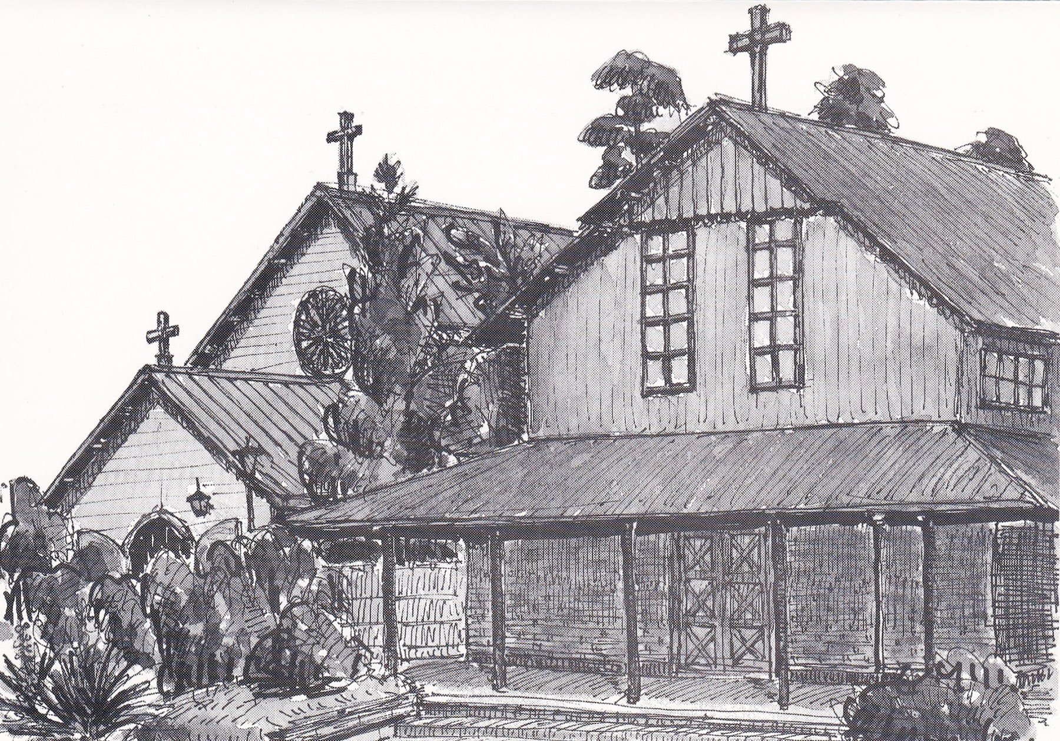
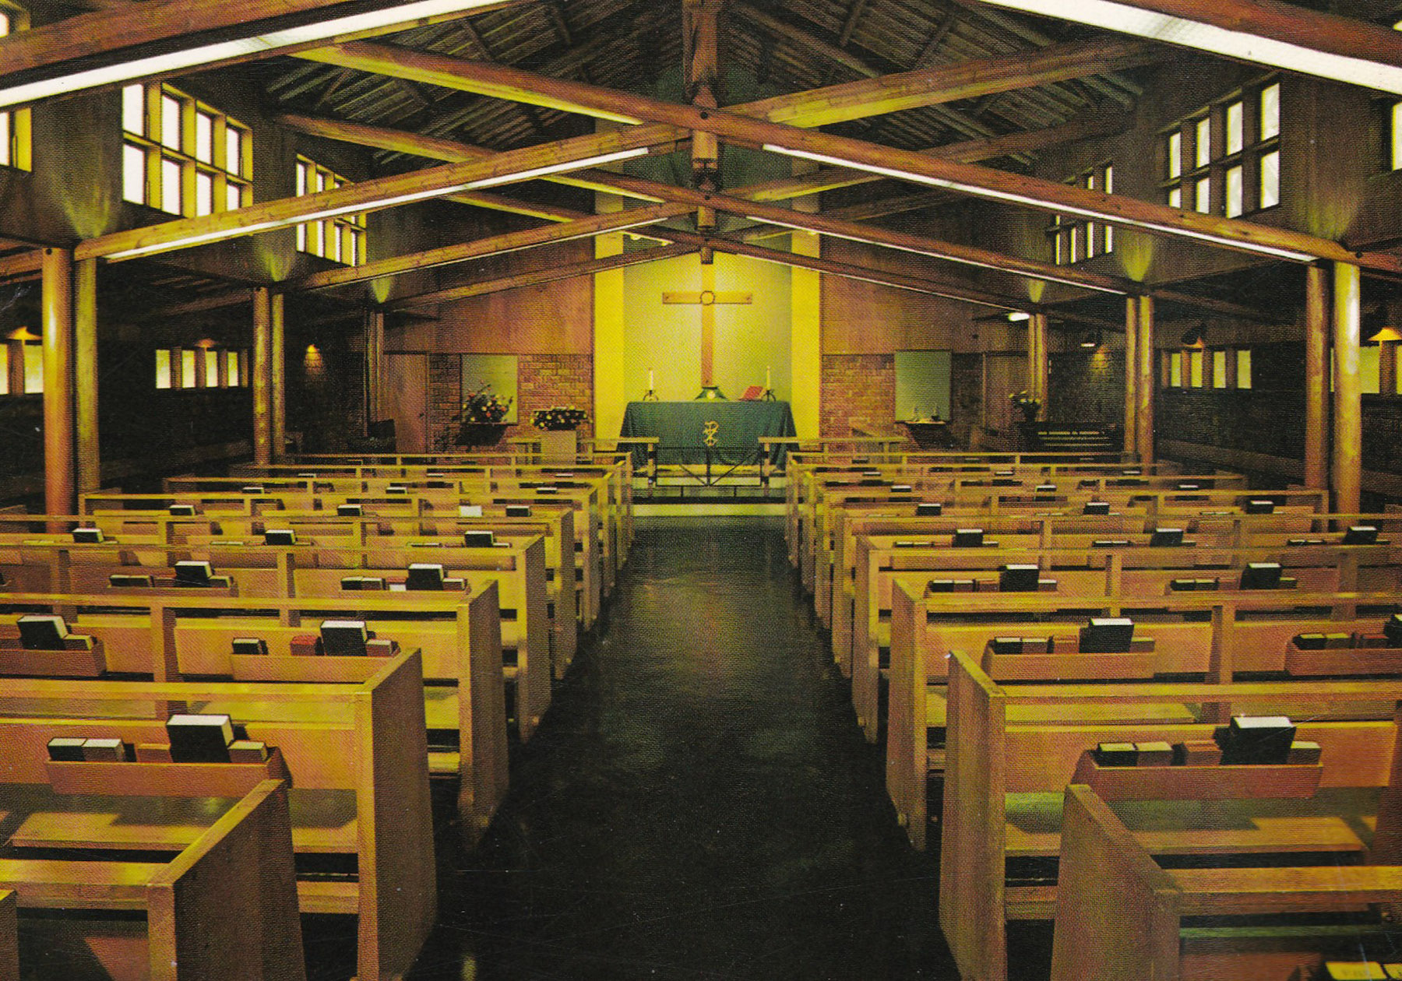
With wedding, reception and airline tickets booked this was an unexpected hiccup. Eventually the incumbent from the adjacent Japanese-speaking Anglican Church agreed to marry us - in English. He would later become the Bishop of Tokyo but had sadly retired when we returned last Autumn.
As part of the Nippon Sei Ko Kai (NSKK - The Anglican Communion in Japan) worship follows the familiar liturgy from the Book of Common Prayer known worldwide, but with slight variations used in the NSKK and translated back into English! Since 1879, English language services in the Anglican tradition have been conducted on the site where St Alban’s now stands, albeit with a break during WWII. Eventually, in 1954, St Alban’s Anglican Episcopal Church was founded specifically as an English language church in the NSKK. It stands just a few yards from the (Japanese-speaking) St Andrew’s Cathedral Church of Tokyo although, apart from some joint committees, the congregations and worship remain separate. Nevertheless, St Alban’s continues to be the thriving multi-cultural congregation we joined 30 years ago, one which is outward-looking in its ministry and able to donate 10% of its annual income to community service organisations!
Meryll Goodwin
________________________________________________

* * Items for Sale * *
Please remember that there is an on-line FoStA Shop.
***
Many thanks to the majority who have returned their GDPR consent forms duly completed. If you haven’t returned yours yet there is still time. Ed

Dates for Your Diary
- Friday 24^{th,} Saturday 25th & Monday 27th May inclusive Flower Festival at St. Andrew’s from 10am to 4pm
- Saturday 25th at 7pm for 7.30pm Anniversary Dinner at An Mor, Hartland Terrace, Bude
- Sunday 26th May 10.30am at St Andrew’s Parish Mass – followed by lunch in the church.
- Saturday 15th June Stratton Summer Fete at Long Paddock, Howard Lane from 1.30pm – 5pm
- Wednesday 19th June Visit of Cornwall Association of Local Historians - to Stratton & Poughill 10am to 3.15pm. There will be two presentations – one regarding the Stratton Churchwardens’ Accounts and another about the Pew Ends in both churches. A guided tour of Stratton will follow.

The online monthly calendar is kept up to date by our Web Master with services and events so do check for further details at www.fosta.org.uk

You are cordially invited to a FoStA Anniversary Dinner at An Mor, Hartland Terrace, Bude on Saturday 25th May 2019 at 7 for 7.30pm
All-inclusive tickets at £36 each.

Come and help us CELEBRATE
Please send requests for tickets, with payment to Mrs Val Barker, Membership Officer, Chynoweth, Bowden, Stratton, Cornwall. EX23 9BH.
Telephone: 01288 353435

I wish to purchase………... tickets Enclosed is a cheque, payable to FoStA for £………………………………… or payment may be made direct to the FoStA bank account at: TSB Sort Code: 30-91-41 Account No. 00586386. Please mark your payment An Mor Dinner.

Name……………………………………………………..
Address…………………………………………………………………………………………...……………………..…………………………………………………………….…………………………………………………….
Telephone Number………………………………………..
Email Address…………………………………………......

FoStA Newsletter is published by
St Andrew’s Church, Stratton, Cornwall. EX23 9DW
Members are sent a copy by post and
a PDF version is available on the FoStA web site - www.fosta.org.uk

Rural Dean: Father David Barnes
1 Lanvean, Cleavelands, Stratton, Bude. EX23 8LJ
Tel: 01288 352254 e-mail: d.barnes645@btinternet.com

Honorary President: Revd Dr David C Standen

Newsletter Editor: Mrs Val Barker
Chynoweth, Bowden, Stratton, Bude EX23 9BH
Tel: 01288 353435 e-mail: memsec@fosta.org.uk

** If you are prepared to view the newsletter on-line or print it yourself, please let me know. **

